# Introduction

## Background

With the widespread prevalence of mobile smart devices, people carry an entire system capable of tracking their actions wherever they are. The tracking of society to find trends and actions has been around for a long time. However modern mobile phones have placed this technical capability in the hands of independent individuals and researchers as opposed to nation states and giant corporations. Furthermore, the widespread acceptance and complacency among most individuals with regards to privacy and tracking suggest that individuals may tolerate having their actions tracked.

## Project Objectives

This project aims to collect a set of data from a small sample of individuals in order to track their interactions and activities. The data obtained will then be used to determine patterns and activities and preferably be then used to predict movements/actions or even provide relevant suggestions based on the identified activities. The individual will be able to view all data collected about them at any time through a web browser. Patterns and identified activities will also be available only to the individual concerned.

## Scope and Limitations

### Tracked Items

#### Sensors/Actions

-Track Location Data at 5-15second intervals.

lat,lng,alt,accuracy/time

-Track ON/OFF events

on/off/time

-Track unlock events

lock/unlock/time

-Track Device details on register

device details/time

-Track SIM number and Operator Name at startup.

sim number/operator name/time

-Track Connected Network Operator name at 10min intervals

operator name/time

-Track List of WiFi hotspots at 10min intervals

list of wifi ssid/time

-Track List of running tasks at 10min intervals

#### Interactions

-Track Received and Sent Numbers from any incoming/outgoing SMS.

incomming/outgoing, number, time

-Call Logs : Number, duration, incomming/outgoing

number,duration,incomming/outgoing, time

### NOT Tracked

#### Actions

-Photo/Media taken : Not reliable

-Envrionmental Volume: Requires active audio stream

-gyroscope data, compass data

-ambient light data

#### Interactions

-Messaging apps(whatsapp,line), voip apps : not able to track

# Related Work

# Issues and Challenges

## Battery Life

Running a wide variety of sensors constantly has a huge impact on battery life and device operating temperatures.

## Conflict with Existing Applications

Various tracking features may conflict with existing applications installed on an Android device. E.g. for SMS tracking, if “Go SMS Pro” has been installed prior to the tracking application, the SMS information will not be accessible by the application.

# Approach and Methodology

The tracking application will be developed in Android with the backend server running on php due to the low cost of running a php server and the unavailability of an Amazon Trial Instance.

The version control system used will be git hosted on github due to familiarity with git and perceived lack of features of SVN.

The development process will be using an agile process to be able to detect basic actions and data as soon as possible. The various tracking functions will be added in a modular fashion so as not to force a rewrite of existing code.

In order not to drain a device battery life too fast, information captured will be cached for a period of time before being sent to the server for storage and analysis. This will also allow for better encryption and compression of the data to improve security and decrease bandwidth usage.

The data stored on the device will be stored in an object database as opposed to a traditional RDBMS due to speed improvements and coding time improvement. Furthermore, as data will be transferred in JSON format, using an object database will allow for fast and easy conversion to send to the server.

# Project Tasks

## TODO

## Status Update

### Use Case Diagram

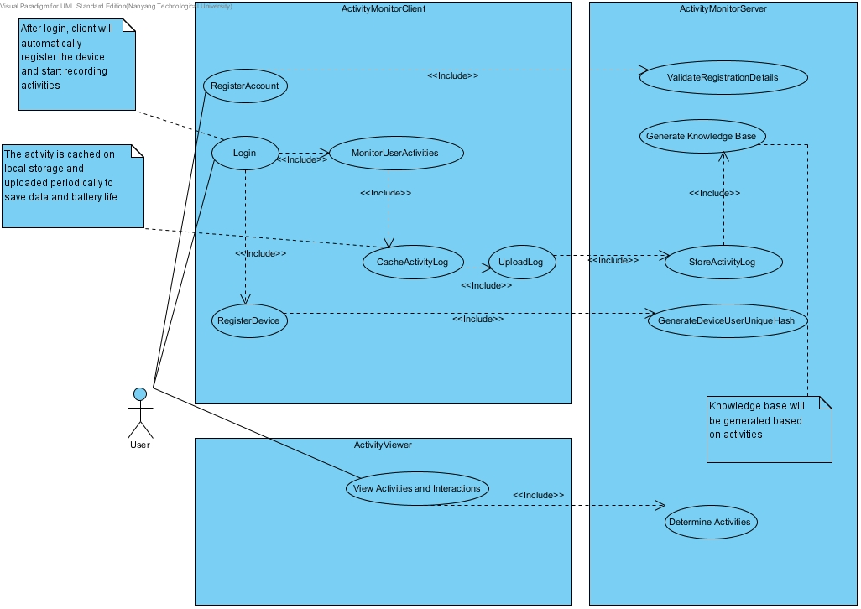

### Entity Relationship Diagram

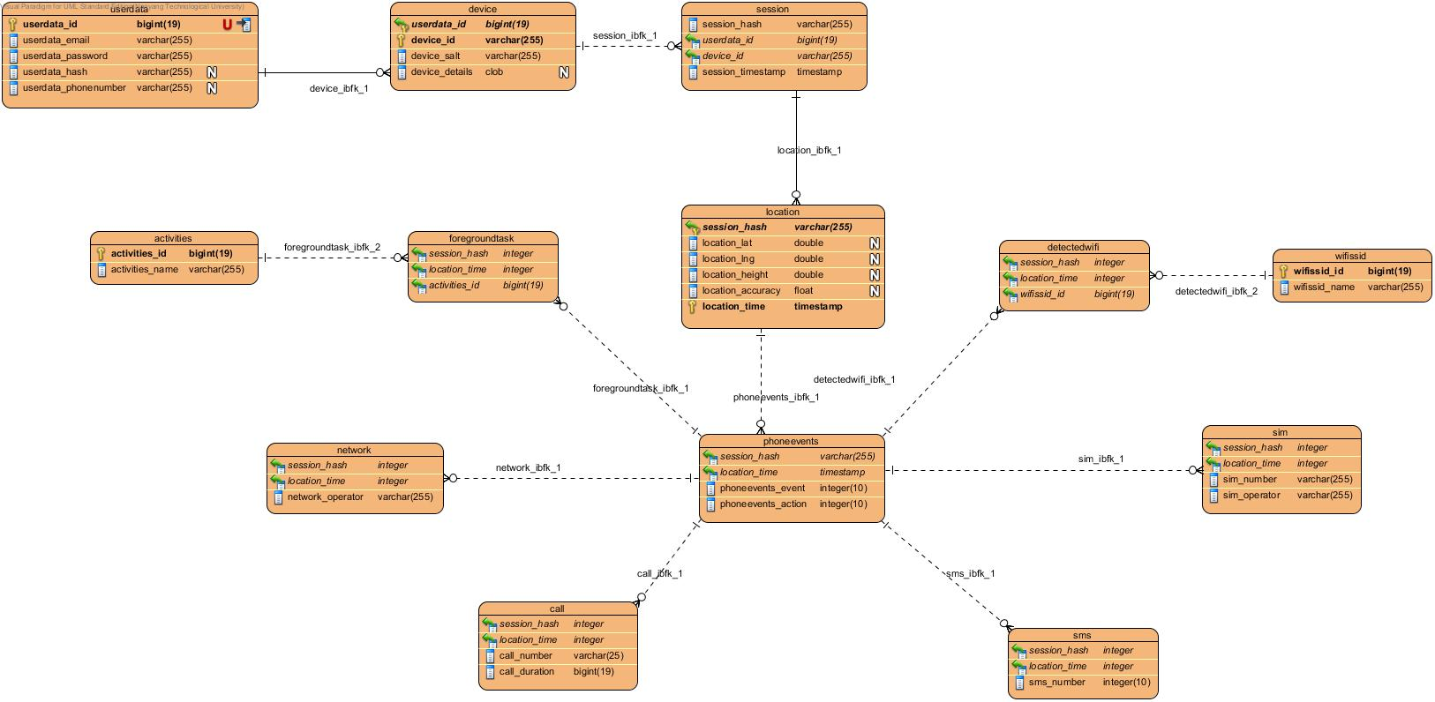

# Schedule

|  |  |  |  |  |  |  |  |  |
| --- | --- | --- | --- | --- | --- | --- | --- | --- |
|  |  | August | September | October | November | December | January | Feburary |
|  |  |  |  |  |  |  |  |  |
| App Development |  |  | | |  |  |  |  |
| Activity Tracking |  |  |  | | | | |  |
| Research Existing Activity Papers |  |  |  | | | |  |  |
| Activity Analysis |  |  |  |  | | | |  |
| Data Mining |  |  |  |  | | | |  |
| Report Writing |  |  |  |  |  |  | | |
| Presentation |  |  |  |  |  |  |  | |